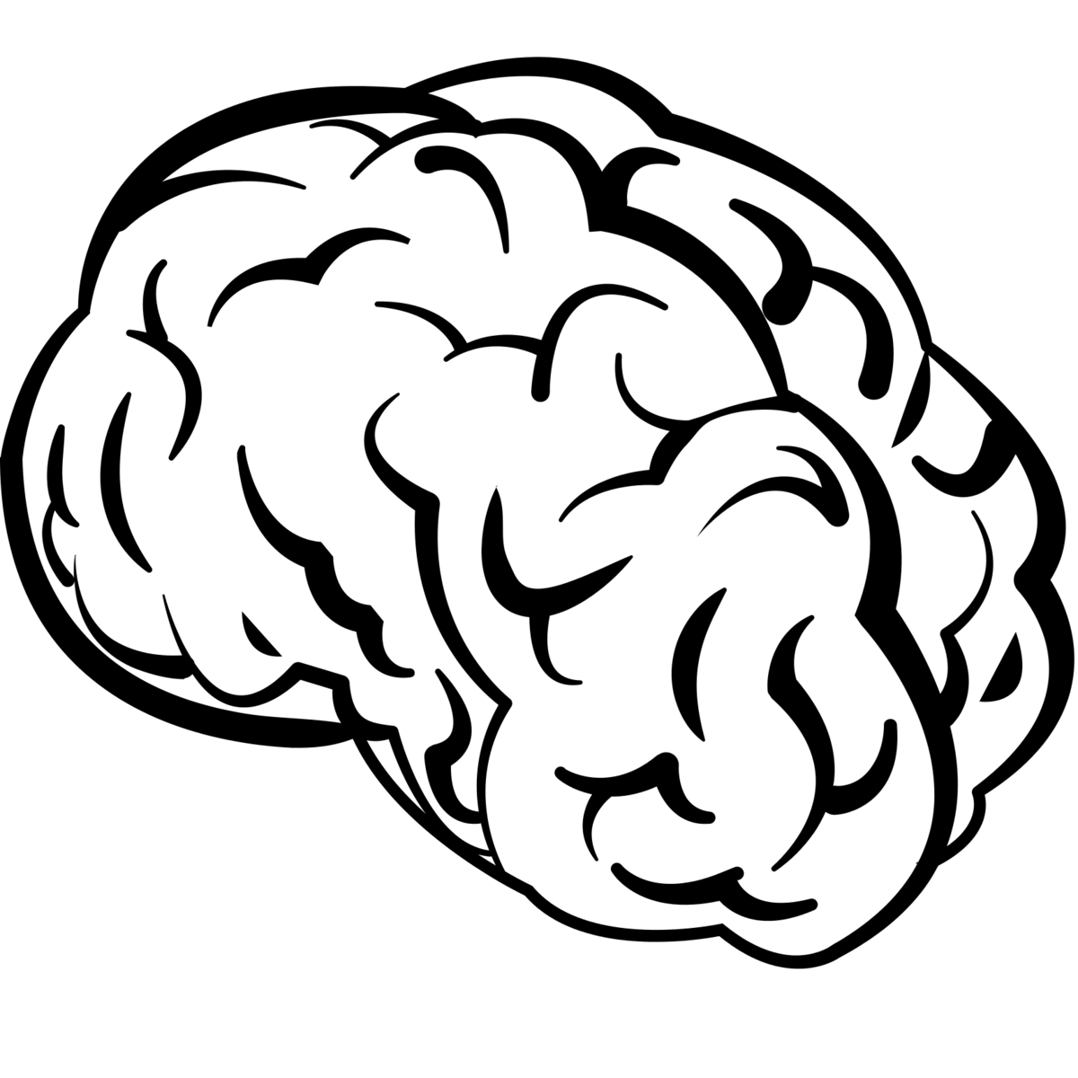

STARVING

SOMEWHAT SATISFIED

FULL

IF ZOMBIES ATE YOUR BRAIN AFTER THIS CLASS, THEY WOULD BE…

Human Translator

Asteroid Miner

Successor to the Overlord

Rocket Lab Assistant

Well, so much for keeping those nuclear launch codes a secret!

Let’s build a fallout shelter of knowledge….

supported with the main points of today’s activity

OUR NEW ALIEN OVERLORD, , IS GIVING YOU A NEW ASSIGNMENT. BASED ON HOW WELL YOU FEEL YOU UNDERSTAND THE CONCEPT/LEARNING TARGET, YOUR NEW JOB IS . . .…

Human Translator

Salt Mine Laborer

aRocket Lab Assistant

Successor to the Overlord

The Global Government Council has botched your brainwashing and “re-education” training!

What confuses you about today’s concepts/learning targets?

Which concept/learning target do you feel has stuffed your brain the most, and WHY?

Which concept/learning target so you feel your brain is completely empty of, and WHY?